## GovHack 2024 6th Sept - 9th Sept: Weka

## Shared Project Document

### Team Members

Bella (Guan, Yongzhen)

Josiah

Sam (Zhu, Sicheng)

### Submission Guidelines

A Hack is when you take something and make it better! This is an open data competition so you need to reuse official open data in a clever and creative way.

Entries could include, art, jewellery, a digital sign, a board game, historic film pieces, a virtual reality game, internet of things (IOT), a digital sensor display, a 3D model, a visualisation of data, an informed article and of course some amazing web apps! We only limit you to your imagination.

It’s only 46 hours, so many of concepts entered are prototypes, mock ups, models, smaller scale artworks and even engineering design concepts from our maker community. Of course we have had some very crafty teams deliver demos and live apps within the time frame.

Your proof of concepts should be showcased in someway in your project page and 3 minute video submission.

### Potential Projects

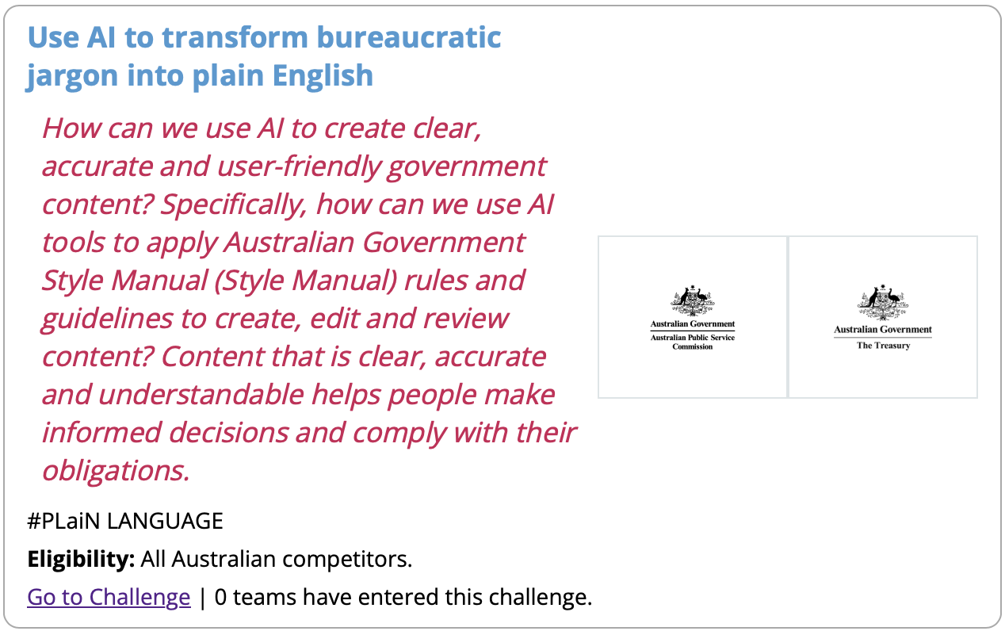

**https://hackerspace.govhack.org/challenges/use_ai_to_transform_bureaucratic_jargon_into_plain_english**

### Tasks

* Continue editing Draft Report
* Work on PowerPoint presentation

## GovHack Event Information

### Project Requirements

1. Description
   1. Purpose of project
   2. How do people use it?
   3. How does it address the challenges?
2. Data Story
   1. What data have you used?
   2. How have you used it?
   3. What can you conclude from the data?
3. Evidence of Work
4. 3 Minute Video
5. (Optional) A public web app for your project
6. A list of Datasets used and GovHack Challenges you have entered

Project Plan

1. Before 11.59pm 06/09/2024 decide which project
2. Before 10am Saturday: build a team
3. Before 4pm Saturday: we have a draft of report
4. Before 9pm Saturday: we have a final report
5. Before 11.59am Sunday we have a draft of video
6. Before 2 pm Sunday we submit the report and video

### GovHack Timeline

#### Friday

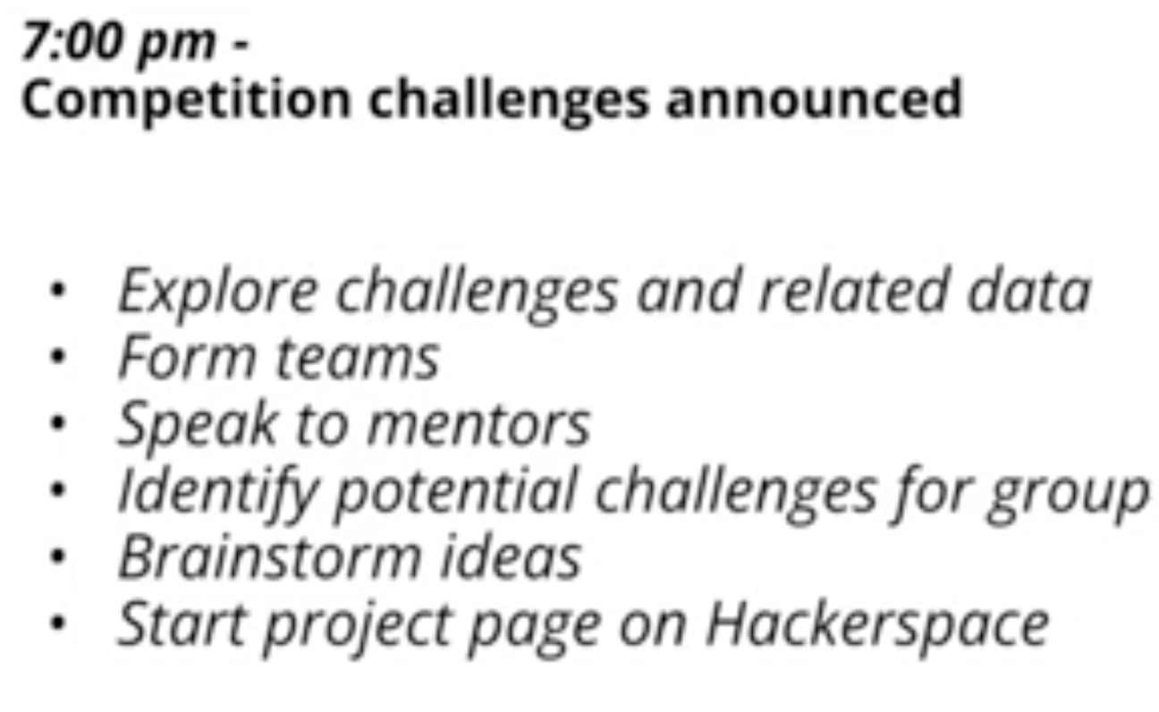

#### Saturday

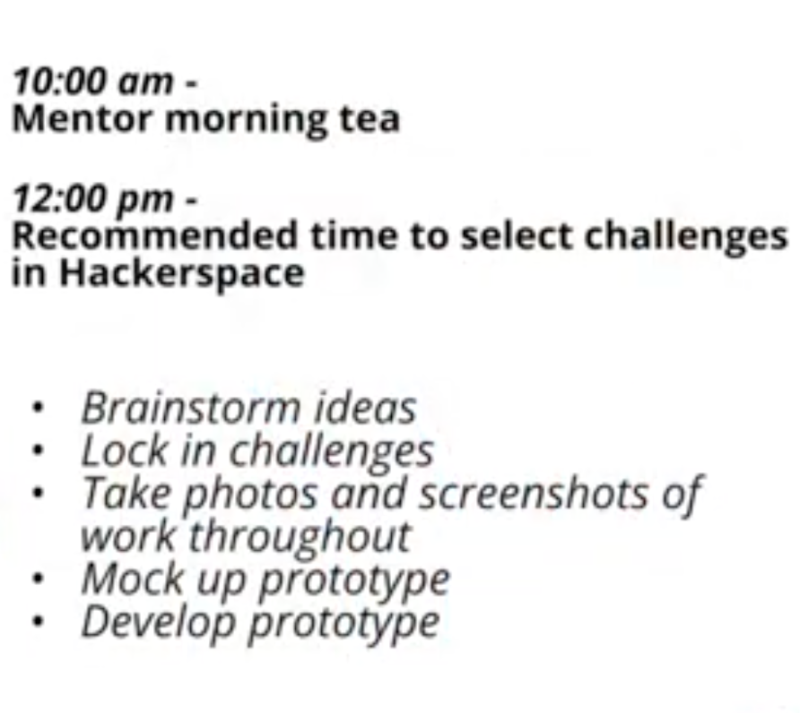

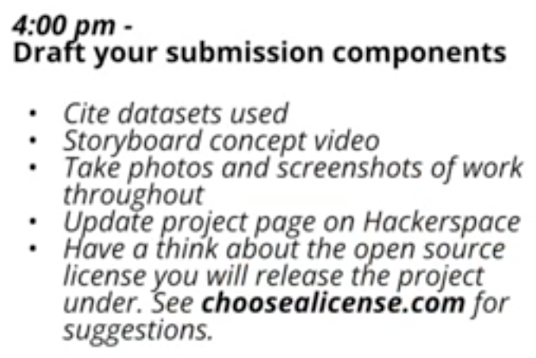

#### Sunday

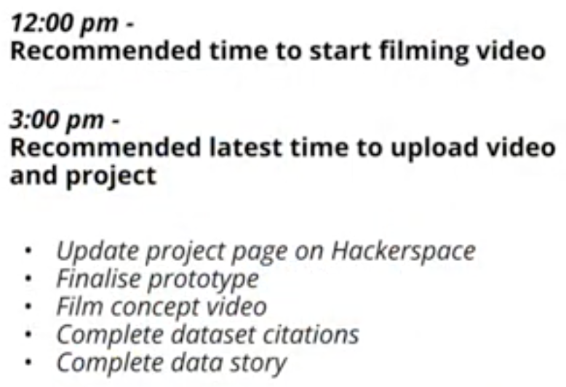

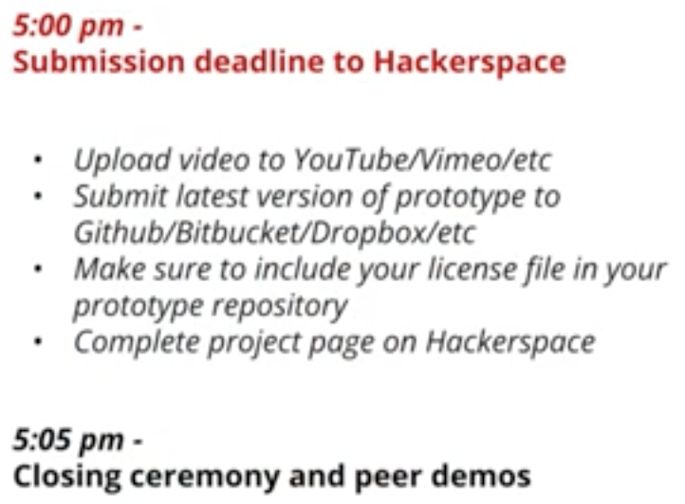

## Project Meetings and Notes

**September 6th: 7pm**

* Initial agreement on two potential projects:
  + Tax Education & Youth Careers

**September 7th: 12:30pm**

* Confirmed we are entering the challenge: **Use AI to transform bureaucratic jargon into plain English**
  + Team project name changed to “AI Jargon Translator”

**Next Meeting is:** **2:00pm September 7th**